Day 5

PS C:\Users\KUDSIT> cd "C:\Users\KUDSIT\Downloads"
PS C:\Users\KUDSIT\Downloads> @'
>> console.log("[*] Corrected Day 5 script");
>>
>> const libc = Process.getModuleByName("libc.so");
>>
>> // Block native Frida detection WITHOUT logging every call
>> const strstr = libc.getExportByName("strstr");
>>
>> Interceptor.attach(strstr, {
>> onEnter(args) {
>> this.block = false;
>> try {
>> const s = args[0].readUtf8String();
>> if (s && s.toLowerCase().includes("frida")) {
>> this.block = true;
>> }
>> } catch (_) {}
>> },
>> onLeave(retval) {
>> if (this.block) retval.replace(ptr(0));
>> }
>> });
>>
>> let xorKey = null;
>> const LEN = 24;
>>
>> // Capture the key from MainActivity.init(byte[])
>> Java.perform(function () {
>> const MainActivity =
>> Java.use("sg.vantagepoint.uncrackable3.MainActivity");
>>
>> const init = MainActivity.init.overload("[B");
>>
>> init.implementation = function (key) {
>> try {
>> xorKey = new Uint8Array(key.length);
>>
>> for (let i = 0; i < key.length; i++) {
>> xorKey[i] = key[i];
>> }
>>
>> console.log("[+] XOR key captured from init()");
>> } catch (e) {
>> console.log("[-] Key capture error: " + e);
>> }
>>
>> return init.call(this, key);
>> };
>>
>> console.log("[+] init(byte[]) hook installed");
>>
>> // Trigger verification once when user presses VERIFY
>> const verify = MainActivity.verify.overload("android.view.View");
>>
>> verify.implementation = function (view) {
>> console.log("[+] verify() called");
>> return verify.call(this, view);
>> };
>>
>> console.log("[+] verify() hook installed");
>> });
>>
>> // Hook native secret generator
>> let generatorHooked = false;
>>
>> const timer = setInterval(function () {
>> if (generatorHooked) return;
>>
>> try {
>> const lib = Process.getModuleByName("libfoo.so");
>> generatorHooked = true;
>> clearInterval(timer);
>>
>> const generator = lib.base.add(0x12c0);
>>
>> console.log("[+] Generator hook installed: " + generator);
>>
>> Interceptor.attach(generator, {
>> onEnter(args) {
>> this.location = args[0];
>> },
>>
>> onLeave(retval) {
>> if (xorKey === null) {
>> console.log("[-] XOR key not available");
>> return;
>> }
>>
>> const encoded =
>> new Uint8Array(
>> this.location.readByteArray(LEN)
>> );
>>
>> const decoded = new Uint8Array(LEN);
>>
>> for (let i = 0; i < LEN; i++) {
>> decoded[i] = encoded[i] ^ xorKey[i];
>> }
>>
>> let hex = "";
>> for (let i = 0; i < LEN; i++) {
>> hex += decoded[i].toString(16).padStart(2, "0") + " ";
>> }
>>
>> let text = "";
>> for (let i = 0; i < LEN; i++) {
>> const c = decoded[i];
>> text += (c >= 32 && c <= 126)
>> ? String.fromCharCode(c)
>> : ".";
>> }
>>
>> console.log("[+] SECRET HEX: " + hex);
>> console.log("[+] SECRET TEXT: " + text);
>> }
>> });
>>
>> } catch (_) {}
>> }, 100);
>> '@ | Set-Content .\day5_correct.js

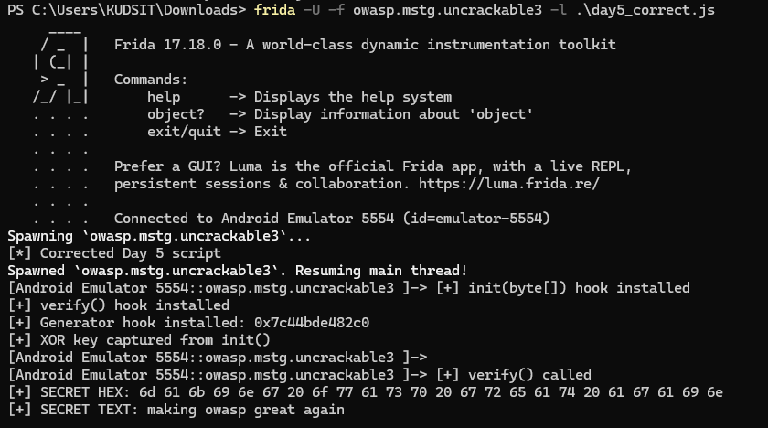

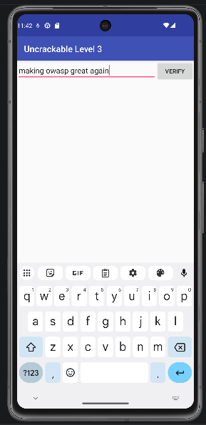

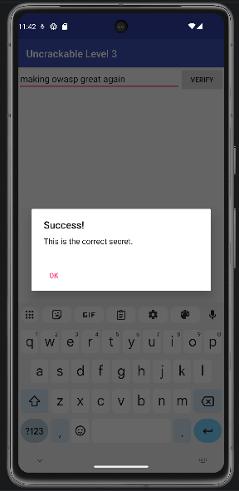

Day 5 — OWASP UnCrackable App for Android Level 3

1. Objective
The objective of this task was to analyze the OWASP UnCrackable-Level3 Android application, identify its anti-tampering and anti-analysis protections, bypass those protections using dynamic instrumentation, and extract the hidden secret stored/generated by the native component.

2. Application Details
Item | Details
Application | OWASP UnCrackable Level 3
Package | owasp.mstg.uncrackable3
Version | 1.0
Version Code | 1
APK | UnCrackable-Level3.apk
SHA-256 | 6827F776B7D2844342711BE6F13695AE8D1A5F209FC0072DBAF8B85E2FCFF4B7
Native Library | libfoo.so
Architectures | ARM64, ARMv7, x86, x86_64
Testing Environment | Android 13 API 33 emulator
Instrumentation Tool | Frida 17.18.0

3. Tools Used
- Android Debug Bridge (ADB)
- Android Emulator
- Frida 17.18.0
- Frida Server
- PowerShell
- 7-Zip
- APK static inspection
- Native library analysis
- Frida Java and native hooks

4. Application Installation
The APK was installed on the Android emulator using:
adb install -r ".\UnCrackable-Level3.apk"
Installation completed successfully.
The package was confirmed using:
adb shell pm path owasp.mstg.uncrackable3
The application contained the native library:
libfoo.so
for multiple CPU architectures.

5. Security Protections Identified
The application implements multiple protections intended to make reverse engineering and dynamic analysis more difficult.

5.1 Java-Level Tamper Detection
The application contains Java-side protection logic that detects tampering and can display a warning before terminating execution.
The MainActivity contains methods including:
verifyLibs()
showDialog()
init(byte[])
baz()
verify(View)
The application therefore performs security-related checks before allowing normal execution.

5.2 Native Frida/Xposed Detection
A major protection mechanism exists inside:
libfoo.so
The native code searches process/library strings for instrumentation frameworks such as:
frida
xposed
The native implementation uses the C library function:
strstr()
If a suspicious string is detected, the application calls its termination routine (goodbye()), causing the process to terminate.

5.3 Native Secret Storage/Generation
The actual secret is not simply present as a plaintext Java string.
The application uses native code in:
libfoo.so
to generate/process the secret.
For the x86_64 library used by the emulator, the relevant secret-generation function was located at:
libfoo.so + 0x12c0

5.4 XOR Obfuscation
The generated secret is obfuscated using XOR.
The application supplies an XOR key through:
MainActivity.init(byte[])
Therefore, obtaining the encoded native data alone does not immediately reveal the plaintext secret.

6. Frida Setup
The emulator was started with root access and Frida Server was running.
Frida connectivity was verified with:
frida-ps -U
The application was then launched using Frida's spawn mode:
frida -U -f owasp.mstg.uncrackable3 -l .\day5_correct.js
Spawn mode was important because the required hooks needed to be installed early during application startup.

7. Bypassing Native Frida Detection
The application's native code uses strstr() to detect suspicious strings.
A Frida hook was therefore placed on the native strstr() function:
const libc = Process.getModuleByName("libc.so");
const strstr = libc.getExportByName("strstr");

Interceptor.attach(strstr, {
onEnter(args) {
this.block = false;

try {
const s = args[0].readUtf8String();

if (s && s.toLowerCase().includes("frida")) {
this.block = true;
}
} catch (_) {}
},

onLeave(retval) {
if (this.block) {
retval.replace(ptr(0));
}
}
});

Result
When the native code searched for "frida", the hook forced strstr() to return NULL.
This prevented the native detection routine from recognizing Frida.

8. Capturing the XOR Key
Instead of attempting to capture an arbitrary strncpy() call, the XOR key was captured directly from the application's Java method:
MainActivity.init(byte[])
The method was hooked using:
const MainActivity =
Java.use("sg.vantagepoint.uncrackable3.MainActivity");

const init = MainActivity.init.overload("[B");

init.implementation = function(key) {

xorKey = new Uint8Array(key.length);

for (let i = 0; i < key.length; i++) {
xorKey[i] = key[i];
}

console.log("[+] XOR key captured from init()");

return init.call(this, key);
};
The following output confirmed successful capture:
[+] XOR key captured from init()

9. Hooking the Secret Generator
The native secret-generation function was located at:
libfoo.so + 0x12c0
The hook was installed using:
const generator = lib.base.add(0x12c0);

Interceptor.attach(generator, {
onEnter(args) {
this.location = args[0];
},

onLeave(retval) {
// Read and decode generated secret
}
});
The successful run confirmed:
[+] Generator hook installed: 0x7c44bde482c0

10. Decoding the Secret
The generated native data consisted of 24 bytes.
The captured XOR key was used to decode the data:
const encoded =
new Uint8Array(
this.location.readByteArray(24)
);

const decoded = new Uint8Array(24);

for (let i = 0; i < 24; i++) {
decoded[i] = encoded[i] ^ xorKey[i];
}
The decoded bytes were then converted into ASCII text.

11. Final Extraction Output
When the application verification function was triggered, Frida produced:
[+] verify() called

[+] SECRET HEX:
6d 61 6b 69 6e 67 20 6f 77 61 73 70 20 67 72 65
61 74 20 61 67 61 69 6e

[+] SECRET TEXT:
making owasp great again

Exact Hidden Secret
making owasp great again

12. Successful Extraction Workflow
The complete successful process was:
Install APK
↓
Start rooted Android emulator
↓
Start Frida instrumentation
↓
Spawn UnCrackable Level 3
↓
Bypass native "frida" detection
↓
Hook MainActivity.init(byte[])
↓
Capture XOR key
↓
Locate libfoo.so
↓
Hook libfoo.so + 0x12c0
↓
Capture generated encoded secret
↓
XOR encoded data with captured key
↓
Decode 24 bytes
↓
Extract plaintext secret

13. Main Frida Techniques Used

Java method hooking
Used to intercept:
MainActivity.init(byte[])
MainActivity.verify(android.view.View)

Native function hooking
Used:
Interceptor.attach()
to intercept native functions.

Native API interception
Intercepted:
libc.so → strstr()
to bypass Frida detection.

Native function offset hooking
Hooked:
libfoo.so + 0x12c0
to capture the generated secret.

Memory reading
Used:
readByteArray()
to extract the generated bytes from native memory.

XOR decoding
The encoded bytes were XORed with the runtime-captured key to recover the plaintext.

14. Security Mechanisms Summary
Protection | Location | Bypass Technique
Java tamper checks | MainActivity | Frida Java hooks
Frida detection | libfoo.so | Hook strstr()
Native termination | libfoo.so | Prevent detection condition
Native secret generation | libfoo.so | Hook generator
XOR obfuscation | Native/Java interaction | Capture key through init(byte[])
Runtime verification | MainActivity.verify() | Frida method hook/observation

15. Conclusion
The OWASP UnCrackable Level 3 application uses a combination of Java-level checks, native anti-instrumentation mechanisms, native secret generation, and XOR-based obfuscation to resist dynamic analysis.
Using Frida, the protections were bypassed by intercepting the native strstr() function, capturing the XOR key from MainActivity.init(byte[]), and hooking the native secret-generation function in libfoo.so.
The encoded 24-byte secret was successfully extracted from native memory and decoded using the captured XOR key.

Final Hidden Secret
making owasp great again
This exercise demonstrated practical techniques for Android dynamic analysis, Java/native Frida instrumentation, anti-Frida bypass, native memory inspection, and runtime secret extraction.

